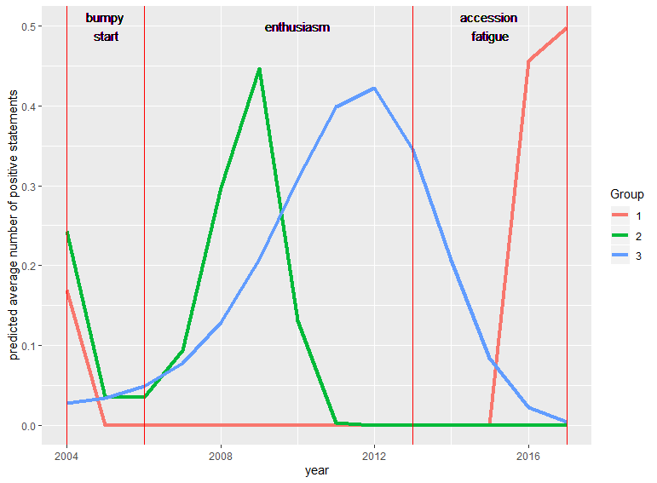

What about the future support for Turkey’s bid to the EU membership? To answer the question, we zoomed in on the support group in the parliament and modelled the number of supportive statements by MPs as a function of time using group-based trajectory analysis (Nagin, 1999). The group-based trajectory model aims to identify distinctive groupings of individual level trajectories within the population using zero-inflated Poisson model. This allows us to disaggregate the support camp and look at the constituting groups in detail. There are two key parameters to specify in the group-based trajectory analysis: the polynomial order of the group trajectories and the number of groups. As noted by Nagin (1999), specifying the polynomial order of group trajectories is a decision based on the expertise on the subject. Higher order polynomials allow the trajectory line to have one more inflection point (i.e. turning point). Considering how contentious the issue of membership and how susceptible it is to the contextual factors; higher polynomial orders are more preferable in our case. To be able to capture the fine changes in the trajectories, we choose the cubic polynomials for group trajectories. Conventional method of selecting the proper number of groups is to iteratively increase the number of groups and choose the model that fits data the best using Bayesian Information Criteria(Nagin & Tremblay, 2005; Niyonkuru et al., 2013; Sweeten, 2014; Wheeler, Worden, & McLean, 2016). However, Nielsen and colleagues (2014) have recently demonstrated that BIC often provides inadequate information for model selection in group-based trajectory analysis. Instead, they recommend using cross validation errors generated by using leave-one-out cross validation method and choosing the number of groups that minimizes the error (Nielsen et al., 2014; Wheeler et al., 2016). Based on the literature, the model that fits our data the best has the cubic polynomial order and 3 groups.

Results of the analysis shows that the support camp in the Turkish parliament is three distinct groups. The group 1 constitutes about 10% of the support camp while group 2 constitutes about 55% of the support camp and the group 3 is about 35% of the support camp. Three distinctive support patterns become obvious when we look at the longitudinal changes in average number of positive statements. Largest member of the support camp (group 2) shows only an episodic support for the membership. Their support reaches a peak during the enthusiasm phase but rapidly declines and drops down to 0 towards the second half of the period. Group 3, on the other hand, shows a more consistent behavior compared to other two groups. Their support steadily increases until the latter half of the enthusiasm period, but their support slowly falters reaching to zero by the end of period we analyzed. Group 1, on the other hand, seems to hold a rather stable position of no support until the mid-accession fatigue period but shows a stark increase in the latter half of accession fatigue.

One possible explanation for the behavior patterns of these groups lies in the justification of the position. Simple crosstabulation of frame use by groups shows that support of MPs in group 2 and group 3 are mostly motivated by their utilitarian reasoning (respectively 39% and 41%) while the group 1 show support based on both reasoning. In other words, MPs’ support for the EU membership in group 2 and 3 is a calculation of tangible costs and benefits of the membership. Unlike the MPs in two other groups, the MPs’ support for the EU membership in group 1 seems to go beyond the utilitarian motivation since 47% of them seem to justify their support with a combination of both normative and utilitarian arguments.

The results from the analysis indicates that future support for Turkey’s membership to EU in Turkish parliament is highly contingent on whether the membership is perceived to be inline with Turkey’s interest or not. Both evidenced by our longitudinal analysis and group-based trajectory analysis, majority of the parliamentarians have already shown a waning enthusiasm towards the membership. In addition, the group-based trajectory analysis has shown that those who supported the Turkish membership to the EU were doing so mostly because of the utilitarian benefits of the EU membership. [**Should we add some differentiated integration/ EU integration theory here? Maybe some citations from Frank**] This is particularly important in conjuncture with increasingly authoritarian regime, Turkey’s security policy in the Middle East, and refugee crisis. There seems to be a little evidence that the support for membership will increase so long as Turkish MPs perceive the membership to the EU contradictory to Turkey’s other interests.

**Table X: Frame use by group:**

|  |  |  |  |  |  |
| --- | --- | --- | --- | --- | --- |
| **Group** | **both** | **Neither** | **Normative** | **Utilitarian** | **Sum** |
| 1 | 47,3 | 10,5 | 21,1 | 21,0 | 100 |
| 2 | 14,5 | 18,4 | 28,1 | 38,8 | 100 |
| 3 | 28,3 | 10,8 | 19,1 | 41,6 | 100 |

**Table X: Group compositions**

|  |  |  |  |  |  |  |
| --- | --- | --- | --- | --- | --- | --- |
| **Group** | **AKP** | **CHP** | **MHP** | **Kurdish Party Family** | **Independents** | **Sum** |
| 1 | 30,7 | 30,7 | 7,7 | 30,7 | 0 | 100 |
| 2 | 54,2 | 24,2 | 11,4 | 10 | 0 | 100 |
| 3 | 43,1 | 36,3 | 6,8 | 9,0 | 4,5 | 100 |

**Table X: Model fit statistics for different number of groups**

|  |  |  |  |  |
| --- | --- | --- | --- | --- |
| **Groups** | **Log-Likelihood** | **AIC** | **BIC** | **CVE** |
| 1 | -700,35 | 1410,71 | 1438,12 | .23 |
| 2 | -679,28 | 1380,56 | 1440,88 | .21 |
| **3** | **-653,45** | **1340,91** | **1434,12** | **.19** |
| 4 | -644,95 | 1335,91 | 1462,03 | Inf |

**Bibliography:**

Nagin, D. S. (1999). Analyzing developmental trajectories: A semiparametric, group-based approach. *Psychological Methods*, *4*(2), 139. https://doi.org/10.1037/1082-989X.4.2.139

Nagin, D. S., & Tremblay, R. E. (2005). What Has Been Learned from Group-Based Trajectory Modeling? Examples from Physical Aggression and Other Problem Behaviors. *The ANNALS of the American Academy of Political and Social Science*, *602*(1), 82–117. https://doi.org/10.1177/0002716205280565

Nielsen, J. D., Rosenthal, J. S., Sun, Y., Day, D. M., Bevc, I., & Duchesne, T. (2014). Group-based Criminal Trajectory Analysis Using Cross-validation Criteria. *Communications in Statistics - Theory and Methods*, *43*(20), 4337–4356. https://doi.org/10.1080/03610926.2012.719986

Niyonkuru, C., Wagner, A. K., Ozawa, H., Amin, K., Goyal, A., & Fabio, A. (2013). Group-Based Trajectory Analysis Applications for Prognostic Biomarker Model Development in Severe TBI: A Practical Example. *Journal of Neurotrauma*, *30*(11), 938–945. https://doi.org/10.1089/neu.2012.2578

Sweeten, G. (2014). Group-Based Trajectory Models. In G. Bruinsma & D. Weisburd (Eds.), *Encyclopedia of Criminology and Criminal Justice* (pp. 1991–2003). https://doi.org/10.1007/978-1-4614-5690-2_479

Wheeler, A. P., Worden, R. E., & McLean, S. J. (2016). Replicating Group-Based Trajectory Models of Crime at Micro-Places in Albany, NY. *Journal of Quantitative Criminology*, *32*(4), 589–612. https://doi.org/10.1007/s10940-015-9268-3